Business Question and Visualization Report

Team ID | MCA
Project Name | Online Education Analytics Dashboard – Student Performance, Engagement & Dropout Analysis
Maximum Marks | 5 Marks

Visualization development refers to the process of creating graphical representations of data to facilitate understanding, analysis, and decision-making. The goal is to transform complex datasets into visual formats that are easy to interpret, enabling users to gain insights and make informed decisions. Visualization development involves selecting appropriate visual elements, designing layouts, and using interactive features to enhance the user experience. This process is commonly associated with data visualization tools and platforms, and it plays a crucial role in business intelligence, analytics, and reporting
Business Questions and Visualisation
The process involves defining specific business questions to guide the creation of meaningful and actionable visualizations in Power BI. Well-framed questions help in identifying key metrics, selecting relevant data, and building visualisation that provide insights.
- What is the overall performance and engagement of students on the platform?
  - Visualization: Card visuals (KPI cards) showing Total Students, Dropout Rate, Average Score, Average Clicks and Pass Rate.
  - Insight: 26K students, a dropout rate of 0.26, an average score of 72.84, 1.62K average clicks and a pass rate of 0.52.
- How are students distributed across regions?
  - Visualization: Clustered column chart of Total Students by region.
  - Insight: Scotland and the East Anglian Region lead with about 2.7K students each, while Ireland is the smallest at about 1.0K.
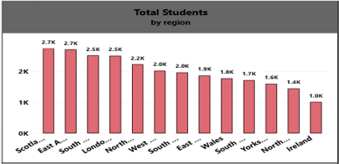
- What proportion of students Pass, Fail, Withdraw or earn a Distinction?
  - Visualization: Donut chart of Total Students by final_result.
  - Insight: Pass is the largest group (12K, 42.37%), followed by Withdrawn (24.15%), Fail (23.13%) and Distinction (10.35%).
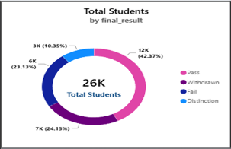
- Does higher engagement lead to higher scores?
  - Visualization: Clustered column chart of Average Score by engagement_level.
  - Insight: Average score rises with engagement, from roughly 66 (Low) to 72 (Medium) and 78 (High).
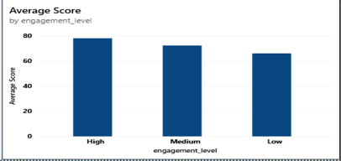
- How much more active are highly engaged students on the platform?
  - Visualization: Clustered column chart of Average of total_clicks by engagement_level.
  - Insight: High-engagement students average 3.7K clicks, versus 0.9K for Medium and 0.2K for Low.
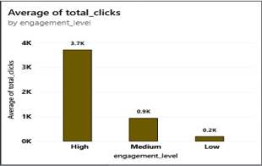
- Does a student's highest education level influence dropout?
  - Visualization: Clustered column chart of Dropout Rate by highest_education.
  - Insight: Dropout falls steadily as prior education rises, from 0.373 (No Formal quals) to 0.219 (Post Graduate).
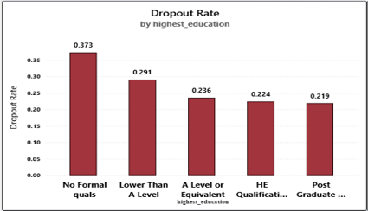
- Which education levels achieve the best pass rates?
  - Visualization: Clustered column chart of Pass Rate by highest_education.
  - Insight: Post Graduate students pass most often (about 0.67) and students with no formal qualifications least (about 0.34).
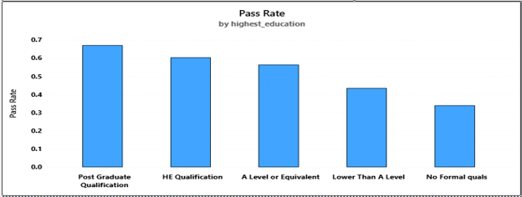
- How are students spread across risk levels?
  - Visualization: Pie chart of Total Students by risk_level.
  - Insight: Very High Risk (26.66%) and High Risk (25.72%) together make up over half of all students; Low Risk is 24.53% and Safe 23.09%.
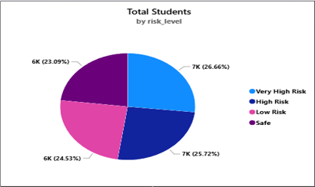
- Do male and female students achieve different outcomes?
  - Visualization: 100% stacked bar chart of Total Students by gender and final_result.
  - Insight: Female students pass more often (44.40% vs 40.70%) and withdraw less (22.18% vs 25.78%) than male students.
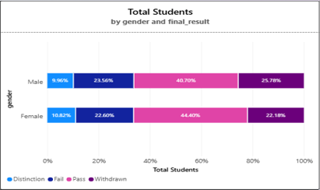
- Does region affect average score?
  - Visualization: Clustered column chart of Average Score by region.
  - Insight: Average score is almost flat across regions (low-to-mid 70s), so region is not a strong driver of performance.
